**Activity: User Reviews**

The User Reviews Activity displays all of the recent reviews a user has received as a driver. The activity consists of a ListView that makes use of a ArrayAdapter in the code behind. The ListView displays several Review Items that show the rating number, the date the review was left, and the user’s comment, if they chose to leave one.

This activity is accessible from any user’s profile when they click the review number, but only if the user has received at least one review.

**Manifest Details**

This activity is implemented with Reveiws.java in the Android Manifest, with its screenOrientation property restricted to “portrait” mode. This activity inherits the app’s theme.

The Intent filter provides standard accessed when referenced by name.

**Layout File(s)**

Activity_reviews.xml

* The sole layout file, containing a single ListView, wrapped in a ConstraintLayout.
* reviewsListView
  + Displays several item_review layouts, making use of an ArrayAdapter in the code behind.

Item_review.xml

* A single Review Item. This displays a single user’s review, including a rating bar, the date the review was left, and the actual comment. All of these views are set in the codebehind.

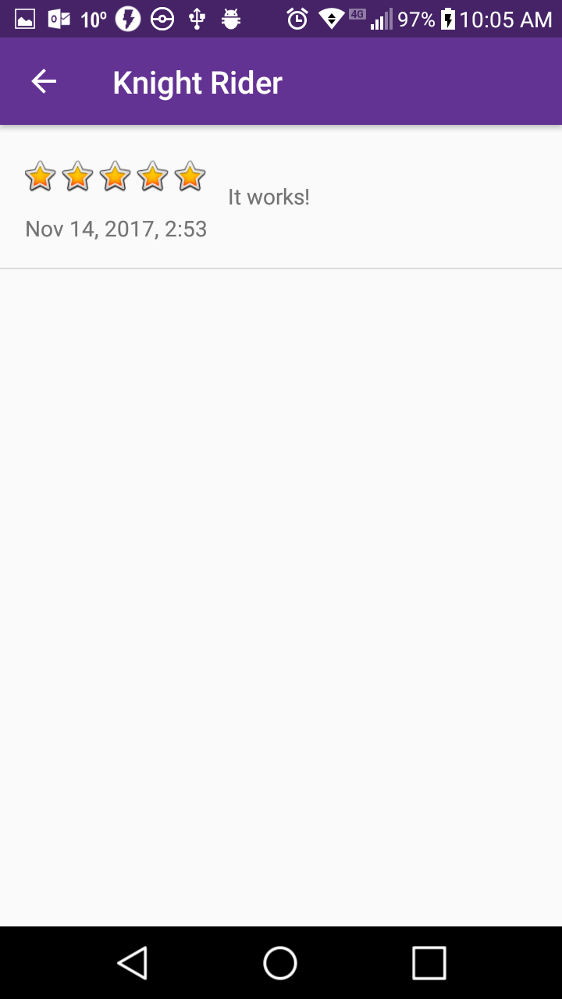

**Class File(s)**

Review.java

* This class implements the User Reviews Activity. It’s a simple class that pulls all the reviews a user has received, and uses an ArrayAdapter to display them as Review Items.
* Variables
  + –prefs: SharedPreferences – Gets the user’s access token
  + –driverId: String --Technically it should be called “userId”, but right now, only drivers can receive reviews. So this variable implies the user was a driver at one point.
* Methods and Classes
  + *onCreate(savedInstanceState): void
    - Displays the activity_reviews layout, initializes “prefs”, creates the back button in the app’s toolbar, and calls the getAllReviews() method.
  + +onOptionsItemSelected(item): Boolean
    - Return the user to the previous screen when the back button is tapped.
  + –getAllReviews(): void
    - Sends a JSON Object GET request (Yes, Object, not Array) to return a driver object that contains an array of reviews.
    - The Reviews are in a JSON Array stored inside the driver object.
    - First, the Activity creates an ArrayList of HashMaps, gets the driverId from the StringExtra sent with the Intent, and puts it in the request url. A RequestQueue is created to send JSON Requests.
    - From the response, the method retrieves the JSON Array named “reviews” and loops through them. In each iteration it creates a new JSON Object from a single review, creates a HashMap, and stores the date, score, and comment. Then the HashMap is stored in the ArrayList.
    - After the loop, the ArrayList is passed into the ArrayAdapater to populate the ListView with RideItems.
  + –ReviewAdapter
    - An ArrayAdapter that handles data from an ArrayList and displays them in a list of Review Items.
    - Variables
      * -reviews: ArrayList<HashMap> -- Stores the ArrayList from getAllReviews()
    - Methods
      * ReviewAdapter(context, reviews)
        + Store the reviews ArrayList
      * +getView(position, convertView, parent): View
        + Inflates the Review Item layout,
        + Get a single review, and store it in a HashMap
        + Set the views in the Review item in their appropriate variables
        + Return the Review Item